**Experiment – 2.1**

**Student Name: Yash Gupta           UID: 20BCS5009**

**Branch: CSE     Section: 709 - A**

**Subject Name: Computer Networks Lab**

**Subject Code: 20CSP-257**

**Aim:-**

**Create a hybrid network using at least two different types of topologies.**

**BUS – Star**

* **In a bus topology, all nodes in the network are connected directly to a central cable that runs up and down the network - this cable is known as the backbone. Data is sent up and down the backbone until it reaches the correct node.**
* **Star topology is a network topology in which each network component is physically connected to a central node such as a router, hub or switch.**

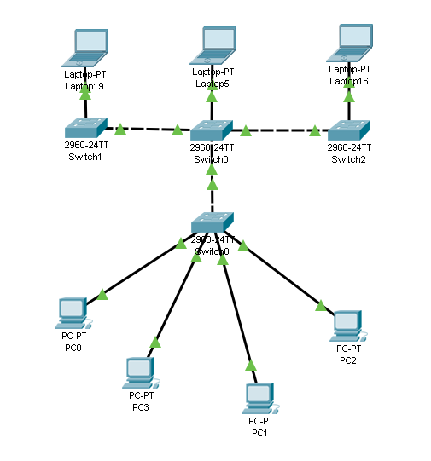

**BUS – Ring**

* **In a bus topology, all nodes in the network are connected directly to a central cable that runs up and down the network - this cable is known as the backbone. Data is sent up and down the backbone until it reaches the correct node.**
* **A ring topology is a network configuration where device connections create a circular data path. Each networked device is connected to two others, like points on a circle. Together, devices in a ring topology are referred to as a ring network.**

